VI. Machine Learning Experimentation

This project adopts a structured and iterative machine learning experimentation process to ensure reliable performance, fairness, and responsible deployment. The experimentation phase covers data preparation, model training, evaluation, and auditing using the Responsible AI (RAI) Dashboard.

Data Preparation and Feature Engineering

The dataset consists of numerical landmark coordinates extracted using MediaPipe Pose and Hands. Upper-body pose landmarks and both hand landmarks are captured and normalized relative to the nose position to achieve translation invariance. This approach reduces the influence of camera positioning and user distance. All features are stored as anonymized numerical values in CSV format, with no raw images or videos retained.

Prior to training, the dataset undergoes a rigorous cleaning process. Rows containing missing values (NaN) are removed, and only relevant feature columns are preserved. To prevent class imbalance, a balancing strategy is applied whereby the number of samples per gesture class is limited to the minimum available class count, subject to a minimum threshold of 30 samples per class. If this requirement is not met, model retraining is deferred, ensuring data sufficiency and training stability.

Model Training Strategy

Three classical machine learning models are trained and evaluated: Random Forest (RF), Support Vector Machine (SVM), and K-Nearest Neighbors (KNN). These models were selected to provide a meaningful comparison across ensemble-based, margin-based, and instance-based learning approaches.

Random Forest is trained using multiple decision trees to capture non-linear relationships within high-dimensional landmark features. SVM is implemented with a linear kernel and probability estimation enabled to support confidence-based prediction. KNN is trained as a distance-based baseline model to evaluate local similarity behavior in the feature space. All models are trained using the same balanced dataset to ensure fair comparison.

Evaluation Using RAI Dashboard

Model evaluation is conducted using the Responsible AI Dashboard, focusing on error distribution, prediction consistency, and fairness across gesture classes. The True Label versus Predicted Label charts provide insight into class-wise performance and misclassification patterns.

The Random Forest model demonstrates strong diagonal alignment in the charts, indicating high prediction accuracy and consistency across all gesture classes. The SVM model shows moderate performance but exhibits increased confusion among gestures with overlapping spatial characteristics. In contrast, the KNN model displays noticeable dispersion across predicted classes, highlighting sensitivity to noise and high-dimensional feature overlap.

Model Selection
Random Forest 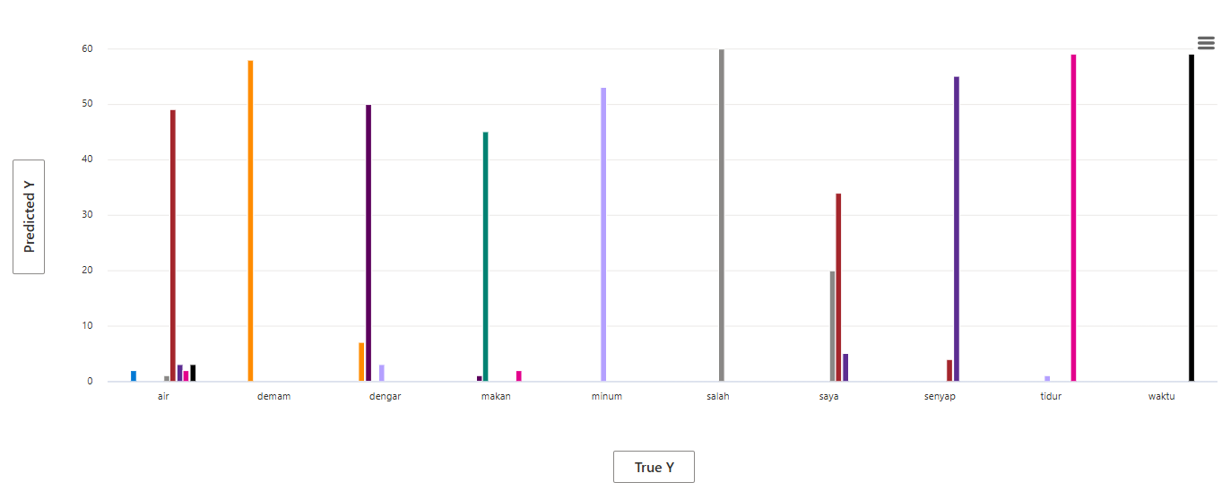
SVM 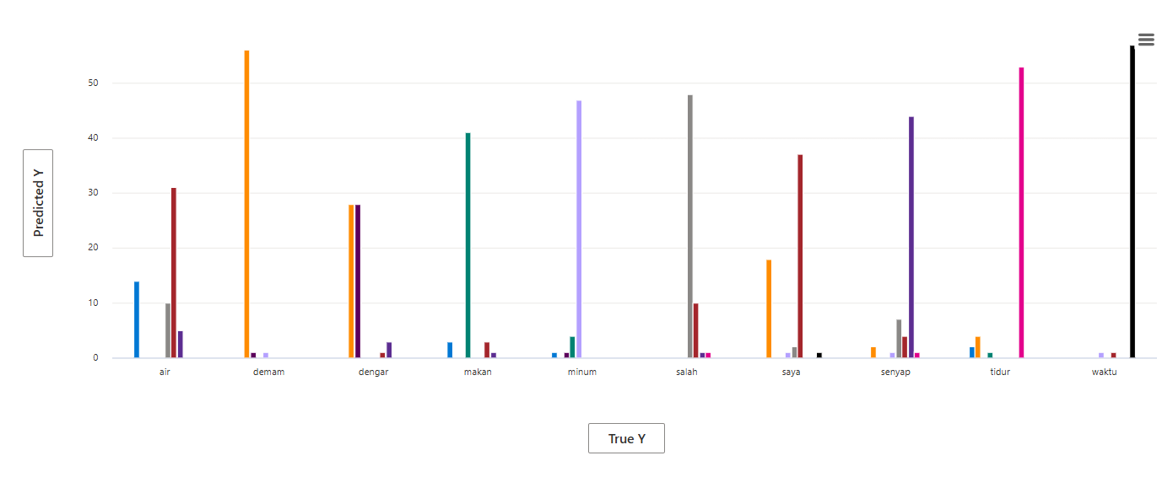

KNN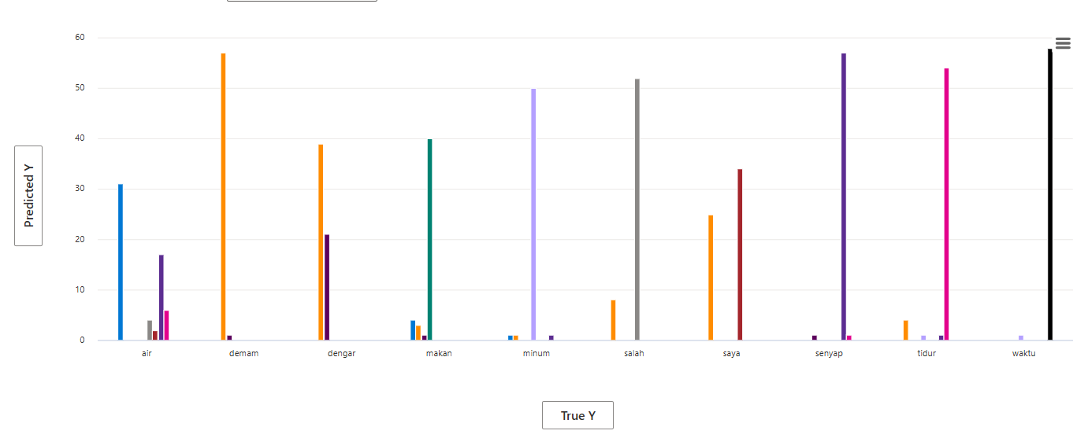
Based on the comparative analysis of the RAI Dashboard charts, Random Forest was selected as the final model for this system. The chart visualizations show that Random Forest predictions are strongly concentrated along the diagonal between true and predicted labels, indicating high class-wise consistency and minimal misclassification across gesture categories.In comparison, the KNN model exhibits significant prediction dispersion, particularly among visually similar gestures such as air, dengar, and saya, reflecting sensitivity to noise and high-dimensional landmark features. Although SVM demonstrates moderate performance, it shows increased confusion when gesture boundaries overlap.
Using fairness analysis from the RAI Dashboard, Random Forest was selected because it demonstrates the most uniform error distribution across gesture classes, reducing disparate impact and ensuring equitable model performance for all signs. Its ensemble-based learning structure enables robust handling of non-linear feature relationships, making it the most reliable and fair model for real-time sign language recognition deployment.

